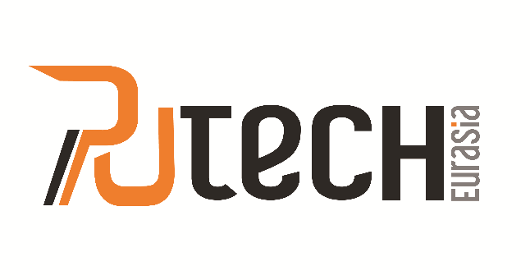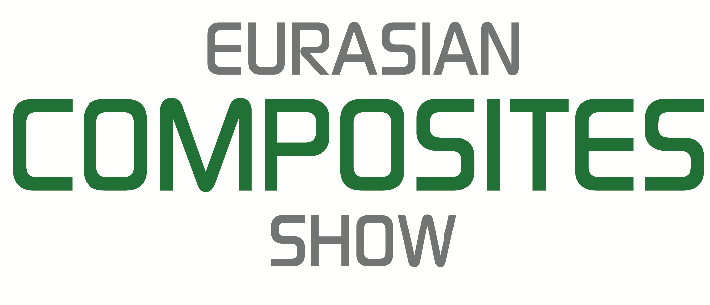

PressRelease 23.06.2017

EURASIA’S LEADING POLYURETHANE AND COMPOSITES PLATFORM

“5th International Polyurethane Industry Exhibition” Putech Eurasia &
“3rd International Composite Industry Exhibition” Eurasian Composites Show 2017

Putech Eurasia & Eurasian Composites Show 2017, which is Eurasia’s largest polyurethane and composites platform, will be bringing together industry professionals from all around the world between 9 - 11 November 2017 at Istanbul Expo Center Halls 9 & 10.

With the development of material science, producing more appropriate materials both economically and technically has become a common goal of the sectors. At this point, composites and polyurethane applications have become indispensable in many sectors such as Automotive, Marine, Building & Insulation, Medical and Sports Sectors, Aviation and Defense Industry.

With the expertise of Artkim Fuarcılık, Putech Eurasia & Eurasian Composites Show 2017 has become a successful organization, which leading companies in the polyurethane and composite industries can demonstrate all services and technologies to domestic and foreign sector professionals and open the doors to new collaborations.

“5th International Polyurethane Industry Exhibition” Putech Eurasia 2017 will give the exhibitors a chance to display polyurethane raw materials, PU products and systems, materials & semi-finished products, PU applications, processing machinery, systems &equipments and services whereas concurrently held “3rd International Composites Industry Exhibition” Eurasian Composites Show 2017 will be providing a platform for its exhibitors to showcase composites raw materials, reinforcements &fibers, composites intermediate products, semi-finished and finished products, processing procedures, finishing & moulding systems and services.

The Buyer’s Mission Committee organization will be held with coordination of the Ministry of Economy in the exhibition and a platform,where potential buyers from many countries meet with participants, will be established.

The exhibition will host End Products Showcases named Live Composites and Live PU which will create a chance to see the daily life usage of the produced products with composite and polyurethane raw materials that are used in almost every sector.

Putech Eurasia & Eurasian Composites Show 2017 will provide a more effective exhibition experience for exhibitors and visitors with its events. In order tostrengthen sectoral information sharing, participants will get the opportunity to present their the latest technology and products in the Workshop / Presentation Program which will be realized simultaneously with the exhibition. AlsoB2B Meeting Event will allow the exhibitor companies and visitors to hold face to face meetings with appointment to build stronger business connections.

Don’t miss the opportunity to be a part of this region’s most important Polyurethane and Composites Platform and take your place among hundreds of leading exhibitor companies from all around the world.

You can find more information on www.putecheurasia.com and www.eurasiancomposites.com and contact us at marketing@artkim.com.tr .

